1.0 Project Report Cover Page

Licensee Information:
Contact Information: Michael B. Henry CD BA FRAI FRSA
Marilyn E. Cornies BA CAHP
Southwestern District Office
553 Dufferin Avenue
London, ON N6B 2A5
Phone: (519) 432-4435
Email: mhenry@amick.ca/mcornies@amick.ca
www.amick.ca
Licensee: Michael B. Henry CD BA FRAI FRSA
Ontario Archaeology Licence: P058

Project Information:
Corporate Project Number: 17366
MTCS Project Number: P058-1629-2017
Investigation Type: Stage 1-2 Archaeological Property Assessment
Project Name: Fifth Wheel
Project Location: 362 & 398 North Service Road, Part of Lots 16 & 17, Concession 1, and Part of Lots 16 & 17, Broken Front Concession and Part of Original Road Allowance between Lots 16 & 17 and Part of Original Road Allowance between Broken Front Concession and Concession 1 (Geographic Township of Grimsby, County of Lincoln) Town of Grimsby, Regional Municipality of Niagara
Project Designation Number: Not Currently Available

MTCS Filing Information:
Site Record/Update Form(s): N/A
Date of Report Filing: TBD
Type of Report: ORIGINAL

2.0 Executive Summary

This report describes the results of the 2017 Stage 1-2 Archaeological Assessment of 362 & 398 North Service Road, Part of Lots 16 & 17, Concession 1, and Part of Lots 16 & 17, Broken Front Concession and Part of Original Road Allowance between Lots 16 & 17 and Part of Original Road Allowance between Broken Front Concession and Concession 1 (Geographic Township of Grimsby, County of Lincoln) Town of Grimsby, Regional Municipality of Niagara, conducted by AMICK Consultants Limited. This study was conducted under Professional Archaeologist License #P058 issued to Michael Henry by the Minister of Tourism, Culture and Sport for the Province of Ontario. This assessment was undertaken as a requirement under the Planning Act (RSO 1990b) and the Provincial Policy Statement (2014) in order to support a Draft Plan of Subdivision application and companion Zoning By-law Amendment application as part of the pre-submission process. Within the land use planning and development context, Ontario Regulation 544/06 under the Planning Act (1990b) requires an evaluation of archaeological potential and, where applicable, an archaeological assessment report completed by an archaeologist licensed by the Ministry of Tourism, Culture and Sport (MTCS). Policy 2.6 of the Provincial Policy Statement (PPS 2014) addresses archaeological resources. All work was conducted in conformity with Ontario Ministry of Tourism and Culture (MTC) Standards and Guidelines for Consultant Archaeologists (MTC 2011), the Ontario Heritage Act (RSO 1990a).

AMICK Consultants Limited was engaged by the proponent to undertake a Stage 1-2 Archaeological Assessment of lands potentially affected by the proposed undertaking and was granted permission to carry out archaeological fieldwork. The entirety of the study area was subject to property inspection and photographic documentation concurrently with the Stage 2 Property Assessment by test pit survey at a ten metre interval to confirm disturbance on August 29, 2017. All records, documentation, field notes, photographs and artifacts (as applicable) related to the conduct and findings of these investigations are held at the Lakelands District corporate offices of AMICK Consultants Limited until such time that they can be transferred to an agency or institution approved by the Ontario Ministry of Tourism, Culture and Sport (MTCS) on behalf of the government and citizens of Ontario.

As a result of the property Assessment of the study area physical evidence of human activity was observed that is too recent to qualify as an archaeological resource and is of no cultural Heritage Value or Interest (CHVI). Accordingly, no archaeological resources were documented./As a result of the Stage 2 Property Assessment of the study area, no archaeological resources were encountered. Consequently, the following recommendations are made:
- No further archaeological assessment of the study area is warranted;
- The Provincial interest in archaeological resources with respect to the proposed undertaking has been addressed;
- The proposed undertaking is clear of any archaeological concern.

3.0 Table of Contents

1.0 Project Report Cover Page 1

2.0 Executive Summary 3

3.0 Table of Contents 4

4.0 Project Personnel 4

5.0 Project Context 5

6.0 Field Work Methods and Weather Conditions 15

7.0 Record of Finds 20

8.0 Analysis and Conclusions 21

9.0 Recommendations 31

10.0 Advice on Compliance with Legislation 33

11.0 Bibliography and sources 34

12.0 Maps 36

13.0 Images 42

4.0 Project Personnel

AMICK Consultants Limited Partners
Michael Henry (MTCS Professional Archaeologist Licence #P058)
Marilyn Cornies (MTCS Professional Archaeologist Licence #P038)

AMICK Consultants Limited Business Manager
Melissa Maclean BBA email mmaclean@amick.ca

Project Coordinator
Melissa Maclean

Project Licensee Archaeologist
Michael Henry (MTCS Professional Archaeologist Licence #P058)

Project Field Directors
Michael Pitul (MTCS Applied Research Archaeologist Licence #R462)

Project Field Assistants
Gary Cole

Project Report Preparation
Michael Pitul (MTCS Applied Research Archaeologist Licence #R462)

Project Graphics
Michael Pitul (MTCS Applied Research Archaeologist Licence #R462)

Project Photography
Michael Pitul (MTCS Applied Research Archaeologist Licence #R462)

5.0 Project Context

5.1 Development Context

This report describes the results of the 2017 Stage 1-2 Archaeological Assessment of 362 & 398 North Service Road, Part of Lots 16 & 17, Concession 1, and Part of Lots 16 & 17, Broken Front Concession and Part of Original Road Allowance between Lots 16 & 17 and Part of Original Road Allowance between Broken Front Concession and Concession 1 (Geographic Township of Grimsby, County of Lincoln) Town of Grimsby, Regional Municipality of Niagara, conducted by AMICK Consultants Limited. This study was conducted under Professional Archaeologist License #P058 issued to Michael Henry by the Minister of Tourism, Culture and Sport for the Province of Ontario. This assessment was undertaken as a requirement under the Planning Act (RSO 1990b) and the Provincial Policy Statement (2014) in order to support a Draft Plan of Subdivision application and companion Zoning By-law Amendment application as part of the pre-submission process. Within the land use planning and development context, Ontario Regulation 544/06 under the Planning Act (1990b) requires an evaluation of archaeological potential and, where applicable, an archaeological assessment report completed by an archaeologist licensed by the Ministry of Tourism, Culture and Sport (MTCS). Policy 2.6 of the Provincial Policy Statement (PPS 2014) addresses archaeological resources. All work was conducted in conformity with Ontario Ministry of Tourism and Culture (MTC) Standards and Guidelines for Consultant Archaeologists (MTC 2011), the Ontario Heritage Act (RSO 1990a).

AMICK Consultants Limited was engaged by the proponent to undertake a Stage 1-2 Archaeological Assessment of lands potentially affected by the proposed undertaking and was granted permission to carry out archaeological fieldwork. The entirety of the study area was subject to property inspection and photographic documentation concurrently with the Stage 2 Property Assessment by test pit survey at a ten metre interval to confirm disturbance on August 29, 2017. All records, documentation, field notes, photographs and artifacts (as applicable) related to the conduct and findings of these investigations are held at the Lakelands District corporate offices of AMICK Consultants Limited until such time that they can be transferred to an agency or institution approved by the Ontario Ministry of Tourism, Culture and Sport (MTCS) on behalf of the government and citizens of Ontario.

The proposed development of the study area includes 1052 residential units, retail space, green spaces, a trail by the lakeshore and visitor parking areas with associated services and landscape modifications. A preliminary plan of the proposed development has been submitted together with this report to MTCS for review and reproduced within this report as Map 4.

5.2 Historical Context

5.2.1 General Historical Outline

The first human settlement in Lincoln County was the Neutral First Nations. The Neutrals resided in the area until 1653, when the Iroquois decimated the Neutral. In 1777 the first European settlers arrived to the area. The majority of the earliest settlers were from Butler’s Rangers, who fought on the side of British during the American War of Independence. The first villages in the area were Jordan , Vineland and Beamsville. United Empire Loyalist Jacob Beam established Beamsville in 1788. Mennonites from the United States established the villages of Jordan and Vineland in 1799. This area became popular for settlers because of the excellent natural resources. As settlements grew numerous businesses were established such as tanneries, mills, and other manufacturing operations. The Twenty Creek provided a natural harbour and was a busy shipping centre for a period of time. Lincoln County was established in 1792, although the first township councils were not formed until 1793 and had no legislative power. The County consisted of 12 townships, which were named after places in Lincoln County in England (Lincoln Public Library 2010).

United Empire Loyalists first settled the town of Grimsby in 1787. The settlement mainly developed around the mouth of Forty Mile Creek. Throughout the town’s history it has been known for manufacturing (farm machinery, hospital furniture and furnaces for example) as well as later establishing itself as the hub of the Niagara Peninsula’s fruit growing industry (grimsbyhistoricalsociety.com)

Map 2 is a facsimile segment from Tremaine’s Map of Lincoln and Welland Counties (Tremaine 1852). Map 2 illustrates the location of the study area and environs as of 1862. The study area is shown to belong to Ezekiel and John Smith; The map illustrates two unnamed stream channel situated immediately east and west of the study area and a settlement road is depicted to the south. This road is the current Queen Elizabeth Way. Accordingly, it has been determined that there is potential for archaeological deposits related to early Post-contact settlement within the study area.

Map 3 is a facsimile segment of the Township of Grimsby map reproduced from The Illustrated Historical Atlas of Lincoln and Welland Counties (H.R. Page & CO. 1876). Map 3 illustrates the location of the study area and environs as of 1876. The study area is shown to belong to George Smith, Edgar Woolverton; an orchard is shown to be within the eastern portion of the study area. Accordingly, it has been determined that there is potential for archaeological deposits related to early Post-contact settlement within the study area. In addition, this map illustrates a settlement road to the south of the study area. This road is the current Queen Elizabeth Way. The map also depicts Lake Ontario directly adjacent to the north of the study area.

It must be borne in mind that inclusion of names of property owners and depictions of structures within properties on these maps were sold by subscription. While information included within these maps may provide information about occupation of the property at a specific point in time, the absence of such information does not indicate that the property was not occupied.

5.2.2 Current Conditions

The present use of the study area is a vacant lot and an active truck washing building. The study area is roughly 6.96 hectares in area. The study area includes within it mostly disturbed land. An abandoned restaurant building is located in the northwest corner of the study are. An active truck wash building is in the center of the study area. There are structural foot prints also located in the western section of the area. The south and central areas are completely disturbed by previous earth movement. Most topsoil has been removed and replaced with crushed stone. There are piles of stone and concrete located in the central and southeastern areas. Two low lying and wet areas are found in the center south and southeast corner also due to soil removal. The northern section of the study area is also disturbed with disturbed soil being piled up right to the lakeshore. The study area is bounded on the north by Lake Ontario, on the east by a residential lot, on the west by North Service Road and parkland and on the south by North Service Road. The study area is approximately 60 metres to the east of the intersection of the Winston Road and North Service Road. A plan of the study area is included within this report as Map 4. Current conditions encountered during the Stage 1-2 Property Assessment are illustrated in Maps 5 & 6.

5.2.3 Summary of Historical Context

The brief overview of documentary evidence readily available indicates that the study area is situated within an area that was close to the historic transportation routes and in an area well populated during the nineteenth century and as such has potential for sites relating to early Post-contact settlement in the region. Background research indicates the property has potential for significant archaeological resources of Native origins based on proximity to a natural source of potable water.

5.3 Archaeological Context

The Archaeological Sites Database administered by the Ministry of Tourism, Culture and Sport (MTCS) indicates that there are no (0) previously documented sites within 1 kilometre of the study area. However, it must be noted that this is based on the assumption of the accuracy of information compiled from numerous researchers using different methodologies over many years. AMICK Consultants Limited assumes no responsibility for the accuracy of site descriptions, interpretations such as cultural affiliation, or location information derived from the Archaeological Sites Database administered by MTCS. In addition, it must also be noted that a lack of formerly documented sites does not indicate that there are no sites present

as the documentation of any archaeological site is contingent upon prior research having been conducted within the study area.

On the basis of information supplied by MTCS, no archaeological assessments have been conducted within 50 metres of the study area. AMICK Consultants Limited assumes no responsibility for the accuracy of previous assessments, interpretations such as cultural affiliation, or location information derived from the Archaeological Sites Database administered by MTCS. In addition, it must also be noted that the lack of formerly documented previous assessments does not indicate that no assessments have been conducted.

Data contained in previous archaeological reports in close proximity to the study area that is relevant to Stage 1 Background Study is defined within the Standards and Guidelines for Consultant Archaeologists in Section 7.5.8 Standard 4 as follows:

“Provide descriptions of previous archaeological fieldwork carried out within the limits of, or immediately adjacent to the project area, as documented by all available reports that include archaeological fieldwork carried out on the lands to be impacted by this project, or where reports document archaeological sites immediately adjacent (i.e., within 50 m) to those lands.”
(MTCS 2011: 126 Emphasis Added)

In accordance with data supplied by MTCS for the purposes of completing this study, there are no previous reports detailing, “archaeological fieldwork carried out on the lands to be impacted by this project”, nor do any previous reports document known archaeological sites within 50 metres of the study area.

The Standards and Guidelines for Consultant Archaeologists stipulates that the necessity to summarize the results of previous archaeological assessment reports, or to cite MTCS File Numbers in references to other archaeological reports, is reserved for reports that are directly relevant to the fieldwork and recommendations for the study area (S & Gs 7.5.7, Standard 2, MTC 2011: 125). This is further refined and elaborated upon in Section 7.5.8, Standards 4 & 5, MTC 2011:

“4. Provide descriptions of previous archaeological fieldwork carried out within the limits of, or immediately adjacent to the project area, as documented by all available reports that include archaeological fieldwork carried out on the lands to be impacted by this project, or where reports document archaeological sites immediately adjacent (i.e., within 50m) to those lands.”
“5. If previous findings and recommendations are relevant to the current stage of work, provide the following:

  - a brief summary of previous findings and recommendations
  - documentation of any differences in the current work from the previously recommended work
  - rationale for the differences from the previously recommended work”
(Emphasis Added)
The study area is situated in area for which there is no archaeological master plan.

It must be further noted that there are no relevant plaques associated with the study area.

5.3.1 Pre-contact Registered Sites

A summary of registered and/or known archaeological sites within a 1-kilometre radius of the study area was gathered from the Archaeological Sites Database, administered by MTCS. As a result it was determined that zero (0) archaeological sites relating directly to Pre-contact habitation/activity had been formally registered within the immediate vicinity of the study area. However, the lack of formally documented archaeological sites does not mean that Pre-contact people did not use the area; it more likely reflects a lack of systematic archaeological research in the immediate vicinity. Even in cases where one or more assessments may have been conducted in close proximity to a proposed landscape alteration, an extensive area of physical archaeological assessment coverage is required throughout the region to produce a representative sample of all potentially available archaeological data in order to provide any meaningful evidence to construct a pattern of land use and settlement in the past

The study area lies approximately directly adjacent to the south of Lake Ontario, which is a source of potable water and a navigable water way. The distance to water criteria used to establish potential for archaeological sites suggests potential for Pre-contact occupation and land use in the area in the past.

Table 1 illustrates the chronological development of cultures within southern Ontario prior to the arrival of European cultures to the area at the beginning of the 17th century. This general cultural outline is based on archaeological data and represents a synthesis and summary of research over a long period of time. It is necessarily generalizing and is not necessarily representative of the point of view of all researchers or stakeholders. It is offered here as a rough guideline and outline to illustrate the relationships of broad cultural groups and time periods.

Table 1 Pre-contact Cultural Chronology for Southern Ontario
Years ago | Period | Southern Ontario
250 | Terminal Woodland | Ontario and St. Lawrence Iroquois Cultures
1000  2000 | Initial Woodland | Princess Point, Saugeen, Point Peninsula, and Meadowood Cultures
3000  4000  5000  6000 | Archaic | Laurentian Culture
7000  8000  9000  10000  11000 | Palaeo-Indian | Plano and Clovis Cultures
 |  | (Wright 1972)

5.3.2 Post-contact Registered Sites

A summary of registered and/or known archaeological sites within a 1-kilometre radius of the study area was gathered from the Archaeological Sites Database, administered by MTCS. As a result it was determined there are zero (0) archaeological sites relating directly to Post-contact habitation/activity had been formally registered within the immediate vicinity of the study area.

5.3.3 Location and Current Conditions

The study area is described as 362 & 398 North Service Road, Part of Lots 16 & 17, Concession 1, and Part of Lots 16 & 17, Broken Front Concession and Part of Original Road Allowance between Lots 16 & 17 and Part of Original Road Allowance between Broken Front Concession and Concession 1 (Geographic Township of Grimsby, County of Lincoln) Town of Grimsby, Regional Municipality of Niagara. This assessment was undertaken as a requirement under the Planning Act (RSO 1990b) in order to support a Draft Plan of Subdivision application and companion Zoning By-law Amendment application.

The present use of the study area is as vacant lot. The study area is roughly 6.96 hectares in area. The study area includes within it mostly disturbed land. An abandoned restaurant building is located in the northwest corner of the study are. An active truck wash building is in the center of the study area. There are structural foot prints also located in the western section of the area. The south and central areas are completely disturbed by previous earth movement. Most topsoil has been removed and replaced with crushed stone. There are piles of stone and concrete located in the central and southeastern areas. Two low lying and wet areas are found in the center south and southeast corner also due to soil removal. The northern section of the study area is also disturbed with disturbed soil being piled up right to the lakeshore. The study area is bounded on the north by Lake Ontario, on the east by a residential lot, on the west by North Service Road and parkland and on the south by North Service Road. The study area is approximately 60 metres to the east of the intersection of the Winston Road and North Service Road. A plan of the study area is included within this report as Map 4. Current conditions encountered during the Stage 1-2 Property Assessment are illustrated in Maps 5 & 6.

5.3.4 Physiographic Region

The study area is located in the Iroquois Plain, which is located on the lowland bordering Lake Ontario. This area used to be under Lake Iroquois and the old shorelines can easily be identified based on unique features such as cliffs, beaches, bars and boulder pavements. Due to the fact that this physiographic region was under a lake, the conditions of the soil and landscape vary greatly from land smoothed by wave action to cliffs. Soil types range from a sandy base to a clay base, with poor drainage in some areas. The Iroquois Plains consists of the area from the Niagara River to the Trent River and around the western end of Lake Ontario. (Chapman and Putnam 1984: 190-196).

5.3.5 Surface Water

Sources of potable water, access to waterborne transportation routes, and resources associated with watersheds are each considered, both individually and collectively to be the highest criteria for determination of the potential of any location to support extended human activity, land use, or occupation. Accordingly, proximity to water is regarded as the primary indicator of archaeological site potential. The Standards and Guidelines for Consultant Archaeologists stipulates that undisturbed lands within 300 metres of a water source are considered to have archaeological potential (MTC 2011: 21).

An unnamed creek is located directly east of the study area, and another to the southwest. These creeks are shown on Tremaine’s Map of Lincoln and Welland Counties (Tremaine 1852). The study area is also directly adjacent to the south of Lake Ontario.

5.3.6 Current Property Conditions Context

Current characteristics encountered within an archaeological research study area determine if property Assessment of specific portions of the study area will be necessary and in what manner a Stage 2 Property Assessment should be conducted, if necessary. Conventional assessment methodologies include pedestrian survey on ploughable lands and test pit methodology within areas that cannot be ploughed. For the purpose of determining where property Assessment is necessary and feasible, general categories of current landscape conditions have been established as archaeological conventions. These include:

5.3.6.1 Buildings and Structural Footprints

A building, for the purposes of this particular study, is a structure that exists currently or has existed in the past in a given location. The footprint of a building is the area of the building formed by the perimeter of the foundation. Although the interior area of building foundations would often be subject to property Assessment when the foundation may represent a potentially significant historic archaeological site, the footprints of existing structures are not typically assessed. Existing structures commonly encountered during archaeological assessments are often residential-associated buildings (houses, garages,

sheds), and/or component buildings of farm complexes (barns, silos, greenhouses). In many cases, even though the disturbance to the land may be relatively shallow and archaeological resources may be situated below the disturbed layer (e.g. a concrete garage pad), there is no practical means of assessing the area beneath the disturbed layer. However, if there were evidence to suggest that there are likely archaeological resources situated beneath the disturbance, alternative methodologies may be recommended to study such areas.

The study area contains several buildings and a structural footprint. The study area contains a abandoned restaurant in the northwest corner. There is a truck wash building centrally located in the study area. There is a structural footprint located in the central west of the study area. Maps 5 & 6 of this report illustrate the locations of this feature.

5.3.6.2 Disturbance

Areas that have been subjected to extensive and deep land alteration that has severely damaged the integrity of archaeological resources are known as land disturbances. Examples of land disturbances are areas of past quarrying, major landscaping, and sewage and infrastructure development (MTC 2011: 18), as well as driveways made of gravel or asphalt or concrete, in-ground pools, and wells or cisterns. Surfaces paved with interlocking brick, concrete, asphalt, gravel and other surfaces meant to support heavy loads or to be long wearing hard surfaces in high traffic areas, must be prepared by the excavation and removal of topsoil, grading, and the addition of aggregate material to ensure appropriate engineering values for the supporting matrix and also to ensure that the installations shed water to avoid flooding or moisture damage. All hard surfaced areas are prepared in this fashion and therefore have no or low archaeological potential. Major utility lines are conduits that provide services such as water, natural gas, hydro, communications, sewage, and others. These major installations should not be confused with minor below ground service installations not considered to represent significant disturbances removing archaeological potential, such as services leading to individual structures which tend to be comparatively very shallow and vary narrow corridors. Areas containing substantial and deeply buried services or clusters of below ground utilities are considered areas of disturbance, and may be excluded from Stage 2 Property Assessment. Disturbed areas are excluded from Stage 2 Property Assessment due to no or low archaeological potential and often because they are also not viable to assess using conventional methodology.
“Earthwork is one of the major works involved in road construction. This process
includes excavation, material removal, filling, compaction, and construction.
Moisture content is controlled, and compaction is done according to standard design
procedures. Normally, rock explosion at the road bed is not encouraged. While filling
a depression to reach the road level, the original bed is flattened after the removal of the topsoil. The fill layer is distributed and compacted to the designed specifications. This procedure is repeated until the compaction desired is reached.
The fill material should not contain organic elements, and possess a low index of
plasticity. Fill material can include gravel and decomposed rocks of a particular size,

but should not consist of huge clay lumps. Sand clay can be used. The area is
considered to be adequately compacted when the roller movement does not create a
noticeable deformation. The road surface finish is reliant on the economic aspects,
and the estimated usage.” [Emphasis Added]
(Goel 2013)

The supporting matrix of a hard paved surface cannot contain organic material which is subject to significant compression, decay and moisture retention. Topsoil has no engineering value and must be removed in any construction application where the surface finish at grade requires underlying support.

Installation of sewer lines and other below ground services associated with infrastructure development often involves deep excavation that can remove archaeological potential. This consideration does not apply to relatively minor below ground services that connect structures and facilities to services that support their operation and use. Major servicing corridors will be situated within adjacent road allowances with only minor, narrow and relatively shallow underground services entering into the study area to connect existing structures to servicing mainlines. The relatively minor, narrow and shallow services buried within a residential property do not require such extensive ground disturbance to remove or minimize archaeological potential within affected areas.

The study area does contain previous disturbances. Most the study area is disturbed. Previous work has stripped most of the top soil away and filled the study area with stone. Piles of stone and crushed concrete are also located on the site. The northern sections of the study area are piled disturbed soil extending to the lake. Maps 5 & 6 of this report illustrate the locations of these features.

5.3.6.3 Low-Lying and Wet Areas

Landscape features that are covered by permanently wet areas, such as marshes, swamps, or bodies of water like streams or lakes, are known as low-lying and wet areas. Low-lying and wet areas are excluded from Stage 2 Property Assessment due to inaccessibility.

The study area does contain low-lying and wet areas. Within the disturbed areas there are two low lying and wet areas. These areas come from top soil removal and recent rain fall. These low lying wet areas are located inside the disturbed areas and therefore do not impact the assessment methodology. Maps 5 & 6 of this report illustrate the locations of these features.

5.3.6.4 Steep Slope

Landscape which slopes at a greater than (>) 20 degree change in elevation, is known as steep slope. Areas of steep slope are considered uninhabitable, and are excluded from Stage 2 Property Assessment.

Generally, steep slopes are not assessed because steep slopes are interpreted to have low potential, not due to viability to assess, except in cases where the slope is severe enough to become a safety concern for archaeological field crews. In such cases, the Occupational Health and Safety Act takes precedence as indicated in the introduction to the Standards and Guidelines. AMICK Consultant Limited policy is to assess all slope areas whenever it is safe to do so. Assessment of slopes, except where safety concerns arise, eliminates the invariably subjective interpretation of what might constitute a steep slope in the field. This is done to minimize delays due to conflicts in such interpretations and to increase the efficiency of review.

The study area does not contain areas of steep slope.

5.3.6.5 Wooded Areas

Areas of the property that cannot be ploughed, such as natural forest or woodlot, are known as wooded areas. These wooded areas qualify for Stage 2 Property Assessment, and are required to be assessed using test pit survey methodology.

The study area does not contain any wooded areas.

5.3.6.6 Ploughable Agricultural Lands

Areas of current or former agricultural lands that have been ploughed in the past are considered ploughable agricultural lands. Ploughing these lands regularly turns the soil, which in turn brings previously buried artifacts to the surface, which are then easily identified during visual inspection. Furthermore, by allowing the ploughed area to weather sufficiently through rainfall, soil is washed off of exposed artifacts at the surface and the visibility of artifacts at the surface of recently worked field areas is enhanced markedly. Pedestrian survey of ploughed agricultural lands is the preferred method of physical assessment because of the greater potential for finding evidence of archaeological resources if present.

The study area does not contain any ploughable lands.

5.3.6.7 Lawn, Pasture, Meadow

Landscape features consisting of former agricultural land covered in low growth, such as lawns, pastures, meadows, shrubbery, and immature trees. These are areas that may be considered too small to warrant ploughing, (i.e. less than one hectare in area), such as yard areas surrounding existing structures, and land-locked open areas that are technically workable by a plough but inaccessible to agricultural machinery. These areas may also include open area within urban contexts that do not allow agricultural tillage within municipal or city limits or the use of urban roadways by agricultural machinery. These areas are required to be assessed using test pit survey methodology.

The study area does not contain any areas of lawn, pasture or meadow.

5.3.7 Summary

Background research indicates the vicinity of the study area has potential for archaeological resources of Native origins based on the proximity to a source of potable water that was also used as a means of waterborne trade and communication. Background research also suggests potential for archaeological resources of Post-contact origins based on proximity to a historic roadway, and proximity to areas of documented historic settlement.

Current conditions within the study area indicate that some areas of the property may have no or low archaeological potential and do not require Stage 2 Property Assessment or should be excluded from Stage 2 Property Assessment. These areas would include the footprint of existing structures, areas under pavement, and areas that are not accessible due to previously dumped stone covering the original surface of the ground. A significant proportion of the study area does exhibit archaeological potential and therefore a Stage 2 Property Assessment is required.

Archaeological potential does not indicate that there are necessarily sites present, but that environmental and historical factors suggest that there may be as yet undocumented archaeological sites within lands that have not been subject to systematic archaeological research in the past.

6.0 Field Work Methods and Weather Conditions

This report confirms that the study area was subject to Stage 2 Property Assessment by by test pit survey at a ten metre interval to confirm disturbance on August 29 2017.

The fieldwork undertaken as a component of this study was conducted according to the archaeological fieldwork standards and guidelines (including weather and lighting conditions). Weather conditions were appropriate for the necessary fieldwork required to complete the Stage 2 Property Assessment and to create the documentation appropriate to this study. The locations from which photographs were taken and the directions toward which the camera was aimed for each photograph are illustrated in Maps 5 & 6 of this report. Upon completion of the property inspection of the study area, it was determined that select areas would require Stage 2 Property Assessment.

It must be noted that AMICK Consultants Limited has been retained to assess lands as specified by the proponent. As such, AMICK Consultants Limited is constrained by the terms of the contract in place at the time of the Archaeological Assessment and can only enter into lands for which AMICK Consultants Limited has received consent from the owner or their agent(s). The proponent has been advised that the entire area within the planning application must be subject to archaeological assessment and that portions of the planning application may only be excluded if they are of low potential, are not viable to assess, or are subject to planning provisions that would restrict any such areas from any form of ground altering activities.

6.3 Test Pit Survey

In accordance with the Standards and Guidelines for Consultant Archaeologists, test pit survey is required to be undertaken for those portions of the study area where deep prior disturbance had not occurred prior to assessment or which were accessible to survey. Test pit survey is only used in areas that cannot be subject to ploughing or cultivation. This report confirms that the conduct of test pit survey within the study area conformed to the following standards:

1. Test pit survey only on terrain where ploughing is not possible or viable, as in the following examples:
a. wooded areas
[Not Applicable – The study area does not contain any wooded areas]

b. pasture with high rock content
[Not Applicable - The study area does not contain any pastures with high rock content

c. abandoned farmland with heavy brush and weed growth
[Not Applicable - The study area does not contain any abandoned farmland with heavy brush and weed growth]

d. orchards and vineyards that cannot be strip ploughed (planted in rows 5 m apart or less), gardens, parkland or lawns, any of which will remain in use for several years after the survey
[Not Applicable - The study area does not contain any of the above-mentioned circumstances]

e. properties where existing landscaping or infrastructure would be damaged. The presence of such obstacles must be documented in sufficient detail to demonstrate that ploughing or cultivation is not viable.
[Not Applicable - The study area does not contain the above-mentioned circumstances]

f. narrow (10 m or less) linear survey corridors (e.g., water or gas pipelines, road widening). This includes situations where there are planned impacts 10 m or less beyond the previously impacted limits on both sides of an existing linear corridor (e.g., two linear survey corridors on either side of an existing roadway). Where at the time of fieldwork the lands within the linear corridor meet the standards as stated under the above section on pedestrian survey land preparation, pedestrian survey must be carried out. Space test pits at maximum intervals of 5 m (400 test pits per hectare) in areas less than 300 m from any feature of archaeological potential.
[Not Applicable – The study area does not contain any linear corridors]

- Space test pits at maximum intervals of 5 m (400 test pits per hectare) in areas less than 300 m from any feature of archaeological potential.
[All test pits were spaced at an interval of 5m between individual test pits]

- Space test pits at maximum intervals of 10 m (100 test pits per hectare) in areas more than 300 m from any feature of archaeological potential.
[The entirety of the test pitted areas of the study area were assessed using high intensity test pit methodology at an interval of 10 metres between individual test pits]

- Test pit to within 1 m of built structures (both intact and ruins), or until test pits show evidence of recent ground disturbance.
[Test pits were placed within 1m of all built structures]

- Ensure that test pits are at least 30 cm in diameter.
[All test pits were at least 30 cm in diameter]

- Excavate each test pit, by hand, into the first 5 cm of subsoil and examine the pit for stratigraphy, cultural features, or evidence of fill.
[Regardless of the interval between individual test pits, all test pits were excavated by hand into the first 5 cm of subsoil where possible and examined for stratigraphy, cultural features, or evidence of fill. In areas where topsoil was not present, test pits were excavated to a minimum of 30cm in depth to ensure that suspected subsoils, if present, were not layers of fill or waterborne materials overlying buried topsoil. If these areas consisted of fill soils, test pits were also excavated a minimum of 30 cm below grade in order to ensure disturbance extended below even deep topsoil layers such as those encountered in agricultural fields to ensure that the depth of disturbance was sufficient to remove archaeological potential in most contexts. Where other evidence indicates locations of potentially significant archaeological sites that may include cultural deposits below fill soils, alternative strategies to explore beneath the fill layers found in some areas may be necessary to complete the Stage 2 Property Assessment. In such cases, further Stage 2 Property Assessment may be recommended following completion of the property survey under conventional methodologies.]

- Screen soil through mesh no greater than 6 mm.
[All soil was screened through mesh no greater than 6 mm]

- Collect all artifacts according to their associated test pit.
[Not Applicable - No archaeological resources were encountered]

- Backfill all test pits unless instructed not to by the landowner.
[All test pits were backfilled]
(MTC 2011: 31-32)

“A combination of property inspection and test pitting may be used when initial Stage 2 results determine that all or part of the project area may in fact be disturbed. The Stage 2 survey may then consists of a detailed inspection (equivalent to Stage 1), combined with test pitting.”

1. If it was not done as part of Stage 1, inspect and document the disturbed areas according to the standards described for Stage 1 property inspections.
[The disturbed areas of the study area were inspected and documented as per the standards described for Stage 1 property inspections. Areas of suspected disturbance where test pit survey was viable were shovel tested as described below. These areas were limited to the south end of the study area in proximity to the beach park pavilion and concrete patio. This area between the artificial beach and the recently constructed pavilion and associated features is considered to be the most likely portion of the study area to produce evidence of the original shoreline and therefore, to retain archaeological potential.

Standard archaeological survey methodologies employed in Ontario for Stage 2 Archaeological Property Assessment (i.e. pedestrian survey and test pit survey) cannot determine if deeply buried cultural remains are or are not present. The purpose of Stage 2 Property Assessment is not to test for deeply buried deposits. The Standards and Guidelines for Consultants Archaeologists recognize this fact and have a whole separate section covering this specific issue. The only way to determine if deeply buried remains are present is to follow those standards not via a standard Stage 1-2 Archaeological Property Assessment.
In most cases, unless there is documentation or evidence to the contrary, areas where grading has exceeded topsoil depth are areas considered to have no or low archaeological potential because in most cases removal of the topsoil will remove archaeological sites. While archaeological sites are popularly thought of as being deeply buried, archaeological sites begin on the surface of the ground and for most of humanity’s history involved no substantial excavations or significant landscape alterations. Only with the rise of urbanization and sedentary settlement do sites begin to accumulate depth. This is a result of continuous building and rebuilding over top of earlier settlements. Deep archaeological sites are created by adding to the surface of an area and building the landform up. Deeply buried archaeological deposits are relatively rare outside of urban environments in Ontario and even within urban contexts, this seldom occurs outside of the historic core of the community where redevelopment has occurred since initial settlement.
If an area was not occupied during a period of potential archaeological significance, there is no potential to locate deeply buried significant archaeological resources. There are only a few very rare exceptions related to historical significance that is not tied to the time period of activity or occupation of a site but to certain historical events and/or personalities.

Areas of suspected disturbance where test pit survey was viable were shovel tested as described below. Areas where soil has been removed were examined using pedestrian survey methodology. The south and central portions of the study area have been subject to topsoil removal below grade and replacement with gravel these areas were walked at 5 metre intervals to assess disturbance. The north of the study area is piled disturbed soils which have been graded. The north area was test pitted at 10 metre intervals to check for disturbance

2. Place Stage 2 test pits throughout the disturbed areas according to professional judgment (and where physically viable) as to confirm that these areas have been completely disturbed.
An area of suspected disturbance was identified during the Property Inspection conducted as part of the Stage 2 Property Assessment. This area consists of an area identified probable disturbance from the piling of disturbed soils and grading of the northern area. Test pits were excavated every 10 metres across the entirety of this portion of the study area. The intensity of test pit survey conducted is far in excess of the minimum standard required. AMICK Consultants Limited tested the suspected disturbed area at a 10-metre interval to confirm disturbance in a manner consistent with the objectives to ensure that the area is accurately delimited and properly identified. There is no requirement to systematically examine such areas.

The Standards and Guidelines require only judgmental testing based on the professional judgment of the investigating archaeologist. In most typical archaeological assessments the entire area of presumed disturbance will be written off as an area of no archaeological potential without thorough testing to demonstrate that the entire area is disturbed or it will be tested at subjective, irregular and inconsistent intervals, and consequently such testing cannot verify that the entire area contained within the presumed limits of disturbance are, in fact, disturbed. The methodology employed here by AMICK Consultants Limited exceeds any requirements of the Standards and Guidelines and that which is generally applied within the industry.

The excavated soil and the profiles of these test pits were examined to determine if each represented an area of disturbance. Test pits were excavated a minimum of 30 cm below grade in order to ensure that test pits were excavated to depths below the surrounding natural grade. This procedure demonstrated that the entire study area consists of fill deposited within a deeply disturbed context. There is no archaeological potential within this area.]
(MTC 2011: 38)

Approximately 90% of the study area consisted of removed topsoil area covered in crushed stone that were examined using pedestrian survey methodology. Approximately 10% of the study area was disturbed soil which has been graded, this area was test pit surveyed at an interval of 10 metres between individual test pits.

7.0 Record of Finds

Section 7.8.2 of the Standards and Guidelines for Consultant Archaeologists (MTC 2011: 137-138) outlines the requirements of the Record of Finds component of a Stage 2 report:

- For all archaeological resources and sites that are identified in Stage 2, provide the following:
  - a general description of the types of artifacts and features that were identified
  - a general description of the area within which artifacts and features were identified, including the spatial extent of the area and any relative variations in density
  - a catalogue and description of all artifacts retained
  - a description of the artifacts and features left in the field (nature of material, frequency, other notable traits).
- Provide an inventory of the documentary record generated in the field (e.g. photographs, maps, field notes).
- Submit information detailing exact site locations on the property separately from the project report, as specified in section 7.6. Information on exact site locations includes the following:
  - table of GPS readings for locations of all archaeological sites
  - maps showing detailed site location information.

7.1 Archaeological Resources

No archaeological resources of any description were encountered anywhere within the study area.

7.2 Archaeological Fieldwork Documentation

The documentation produced during the field investigation conducted in support of this report includes: one sketch map, one page of photo log, one page of field notes, and 57 digital photographs.

8.0 Analysis and Conclusions

AMICK Consultants Limited was engaged by the proponent to undertake a Stage 1-2 Archaeological Assessment of lands potentially affected by the proposed undertaking and was granted permission to carry out archaeological fieldwork. The entirety of the study area was subject to property inspection and photographic documentation concurrently with the Stage 2 Property Assessment on August 29 2017, consisting of high-intensity test pit survey at an interval of ten metres between individual test pits. All records, documentation, field notes, photographs and artifacts (as applicable) related to the conduct and findings of these investigations are held at the Lakelands District corporate offices of AMICK Consultants Limited until such time that they can be transferred to an agency or institution approved by the Ontario Ministry of Tourism, Culture and Sport (MTCS) on behalf of the government and citizens of Ontario.

8.1 Stage 1 Analysis and Conclusions

As part of the present study, background research was conducted in order to determine the archaeological potential of the proposed project area.

“A Stage 1 background study provides the consulting archaeologist and Ministry report reviewer with information about the known and potential cultural heritage resources within a particular study area, prior to the start of the field assessment.” (OMCzCR 1993)

The evaluation of potential is further elaborated Section 1.3 of the Standards and Guidelines for Consultant Archaeologist (2011) prepared by the Ontario Ministry of Tourism and Culture:

“ The Stage 1 background study (and, where undertaken, property inspection) leads to an evaluation of the property’s archaeological potential. If the evaluation indicates that there is archaeological potential anywhere on the property, the next step is a Stage 2 assessment.”
(MTC 2011: 17)

Features or characteristics that indicate archaeological potential when documented within the study area, or within close proximity to the study area (as applicable), include:

“ - previously identified archaeological sites

- water sources (It is important to distinguish types of water and shoreline, and to distinguish natural from artificial water sources, as these features affect site locations and types to varying degrees.):
  - primary water sources (lakes, rivers, streams, creeks)
  - secondary water sources (intermittent streams and creeks, springs, marshes, swamps)
  - features indicating past water sources (e.g., glacial lake shorelines indicated by the presence of raised sand or gravel beach ridges, relic river or stream channels indicated by clear dip or swale in the topography, shorelines of drained lakes or marshes, cobble beaches)
  - accessible or inaccessible shoreline (e.g., high bluffs, swamp or marsh fields by the edge of a lake, sandbars stretching into marsh)
- elevated topography (e.g., eskers, drumlins, large knolls, plateaux)
- pockets of well-drained sandy soil, especially near areas of heavy soil or rocky ground
- distinctive land formations that might have been special or spiritual places, such as waterfalls, rock outcrops, caverns, mounds, and promontories and their bases. There may be physical indicators of their use, such as burials, structures, offerings, rock paintings or carvings.
- resource areas, including:
  - food or medicinal plants (e.g., migratory routes, spawning areas, prairie)
  - scarce raw materials (e.g., quartz, copper, ochre or outcrops of chert)
  - early Post-contact industry (e.g., fur trade, logging, prospecting, mining)
- areas of early Post-contact settlement. These include places of early military or pioneer settlement (e.g., pioneer homesteads, isolated cabins, farmstead complexes), early wharf or dock complexes, pioneer churches and early cemeteries. There may be commemorative markers of their history, such as local, provincial, or federal monuments or heritage parks.
- Early historical transportation routes (e.g., trails, passes, roads, railways, portage routes)
- property listed on a municipal register or designated under the Ontario Heritage Actor that is a federal, provincial or municipal historic landmark or site
- property that local histories or informants have identified with possible archaeological sties, historical events, activities, or occupations”
(MTC 2011: 17-18)

The evaluation of potential does not indicate that sites are present within areas affected by proposed development. Evaluation of potential considers the possibility for as yet undocumented sites to be found in areas that have not been subject to systematic archaeological investigation in the past. Potential for archaeological resources is used to determine if property assessment of a study area or portions of a study area is required.

“Archaeological resources not previously documented may also be present in the affected area. If the alternative areas being considered, or the preferred alternative selected, exhibit either high or medium potential for the discovery of archaeological remains an archaeological assessment will be required.”
(MCC & MOE 1992: 6-7)

“The Stage 1 background study (and, where undertaken, property inspection) leads to an evaluation of the property’s archaeological potential. If the evaluation indicates that there is archaeological potential anywhere on the property, the next step is a Stage 2 assessment.”
(MTC 2011: 17)

In addition, archaeological sites data is also used to determine if any archaeological resources had been formerly documented within or in close proximity to the study area and if these same resources might be subject to impacts from the proposed undertaking. This data was also collected in order to establish the relative cultural heritage value or interest of any resources that might be encountered during the conduct of the present study. For example, the relative rarity of a site can be used to assign an elevated level of cultural heritage value or interest to a site that is atypical for the immediate vicinity. The requisite archaeological sites data of previously registered archaeological sites was collected from the Programs and Services Branch, Culture Programs Unit, MTCS and the corporate research library of AMICK Consultants Limited. The Stage 1 Background Research methodology also includes a review of the most detailed available topographic maps, historical settlement maps, archaeological management plans (where applicable) and commemorative plaques or monuments. When previous archaeological research documents lands to be impacted by the proposed undertaking or archaeological sites within 50 metres of the study area, the reports documenting this earlier work are reviewed for pertinent information. AMICK Consultants
Limited will often modify this basic methodology based on professional judgment to include additional research (such as, local historical works or documents and knowledgeable informants).

Section 7.7.3 of the Standards and Guidelines for Consultant Archaeologists (MTC 2011: 132) outlines the requirements of the Analysis and Conclusions component of a Stage 1 Background Study.

- “Identify and describe areas of archaeological potential within the project area.
- Identify and describe areas that have been subject to extensive and deep land alterations. Describe the nature of alterations (e.g., development or other activity) that have severely damaged the integrity of archaeological resources and have removed archaeological potential.”

Characteristics Indicating Archaeological Potential

Section 1.3.1 of the Standards and Guidelines for Consultant Archaeologists specifies the property characteristics that indicate archaeological potential (MTC 2011: 17-18). Factors that indicate archaeological potential are features of the local landscape and environment that may have attracted people to either occupy the land or to conduct activities within the study area. One or more of these characteristics found to apply to a study area would necessitate a Stage 2 Property Assessment to determine if archaeological resources are present. These characteristics are listed below together with considerations derived from the conduct of this study.

- Previously Identified Archaeological Sites
Previously registered archaeological sites have not been documented within 300 metres of the study area.

- Water Sources
Primary water sources are described as including lakes, rivers streams and creeks. Close proximity to primary water sources (300 metres) indicates that people had access to readily available sources of potable water and routes of waterborne trade and communication should the study area have been used or occupied in the past.

There is one identified primary water sources within 300 metres of the study area. Lake Ontario is directly adjacent to the north of the study area

Secondary water sources are described as including intermittent streams and creeks, springs, marshes, and swamps. Close proximity (300 metres) to secondary water sources indicates that people had access to readily available sources of potable water, at least on a seasonal basis, and in some cases seasonal access to routes of waterborne
trade and communication should the study area have been used or occupied in the past.

There are two identified secondary water sources within 300 metres of the study area. There is an unnamed creek adjacent to the west of the study area and another in the southwest corner of the study area.

- Features Indicating Past Water Sources
Features indicating past water resources are described as including glacial lake shorelines indicated by the presence of raised sand or gravel beach ridges, relic river or stream channels indicated by clear dip or swale in the topography, shorelines of drained lakes or marshes, and cobble beaches. Close proximity (300 metres) to features indicating past water sources indicates that people had access to readily available sources of potable water, at least on a seasonal basis, and in some cases
seasonal access to routes of waterborne trade and communication should the study area have been used or occupied in the past.

There are identified features indicating past water sources within 300 metres of the study area. There are two unnamed creeks located to the east and west of the study area as seen on Tremaine’s Map of Lincoln and Welland Counties (Tremaine 1852)

- Accessible or Inaccessible Shoreline
This form of landscape feature would include high bluffs, swamp or marsh fields by the edge of a lake, sandbars stretching into marsh, etc.

There are shorelines within 300 metres of the study area. The shoreline of Lake Ontario is directly adjacent to the north of the study area.

- Elevated Topography
Features of elevated topography that indicate archaeological potential include eskers, drumlins, large knolls, and plateaux.

There are no identified features of elevated topography within the study area.

- Pockets of Well-drained Sandy Soil
Pockets of sandy soil are considered to be especially important near areas of heavy soil or rocky ground.

The soil throughout the study area is dark brown sand, which is consistent with the wider area surrounding the property. Therefore, the presence of this soil has no impact on potential within the study area, as the wider area is not known for clay soils or exposed bedrock.

The image below (Kuhlmann, Stacy 2017) shows the consistencies of soil types and how they compare to one another. The soil found within the study area was a silt loam, which contains a higher percentage of silt with a lower percentage of sand and an even lower percentage of clay. The lower percentage of clay allows the soil to break up from the action of ploughing alone when not compacted or bound by extensive root masses.
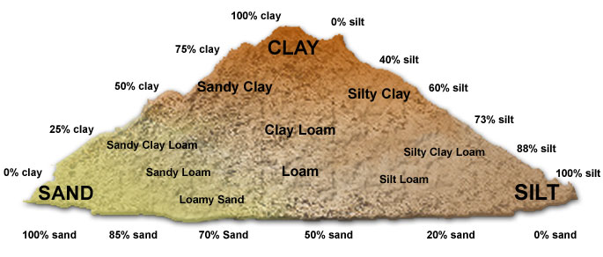
(Kuhlmann, Stacy 2017)

- Distinctive Land Formations
These are landscape features that might have been special or spiritual places, such as waterfalls, rock outcrops, caverns, mounds, and promontories and their bases. There may be physical indicators of their use, such as burials, structures, offerings, rock paintings or carvings.

There are no identified distinctive land formations within the study area

Resource Areas
Resource areas that indicate archaeological potential include food or medicinal plants (e.g., migratory routes, spawning areas, and prairie), scarce raw materials (e.g., quartz, copper, ochre or outcrops of chert) and resources of importance to early Post-contact industry (e.g., logging, prospecting, and mining).

There are no identified resource areas within the study area.

- Areas of Early Post-contact Settlement

These include places of early military or pioneer settlement (e.g., pioneer homesteads, isolated cabins, and farmstead complexes), early wharf or dock complexes, pioneer churches and early cemeteries. There may be commemorative markers of their history, such as local, provincial, or federal monuments or heritage parks.

The study area is situated in close proximity to a historic community identified on the historic atlas map. The study area is in close proximity to the town of Grimsby.

- Early Historical Transportation Routes
This includes evidence of trails, passes, roads, railways, portage routes.

The study area is situated within 100 metres of an early settlement road that appears on the Historic Atlas Map of 1862. This historic road corresponds to the road presently known as Queen Elizabeth Way, which are adjacent to the study area. The property is situated within 300 metres of a body of water that was used for waterborne trade and communication, directly adjacent to Lake Ontario

- Heritage Property
Property listed on a municipal register or designated under the Ontario Heritage Act or is a federal, provincial or municipal historic landmark or site.

There are no listed or designated heritage buildings or properties that form a part of the study area. There are no listed or designated heritage buildings or properties that are adjacent to the study area.

Documented Historical or Archaeological Sites
This includes property that local histories or informants have identified with possible archaeological sites, historical events, activities, or occupations. These are properties which have not necessarily been formally recognized or for which there is additional evidence identifying possible archaeological resources associated with historic properties in addition to the rationale for formal recognition.

There are no known heritage features, or known historic sites, or known archaeological sites within the study area in addition to those formally documented with the appropriate agencies or previously noted under a different criterion.

Characteristics Indicating Removal of Archaeological Potential

Section 1.3.2 of the Standards and Guidelines for Consultant Archaeologists specifies the property characteristics which indicate no archaeological potential or for which archaeological potential has been removed (MTC 2011: 18-19). These characteristics are listed below together with considerations derived from the conduct of this study.

The introduction of Section 1.3.2 (MTC 2011: 18) notes that “Archaeological potential can be determined not to be present for either the entire property or a part(s) of it when the area under consideration has been subject to extensive and deep land alterations that have severely damaged the integrity of any archaeological resources. This is commonly referred to as ‘disturbed’ or ‘disturbance’, and may include:”

- Quarrying
There is no evidence to suggest that quarrying operations were ever carried out within the study area.

- Major Landscaping Involving Grading Below Topsoil

Unless there is evidence to suggest the presence of buried archaeological deposits, such deeply disturbed areas are considered to have lost their archaeological potential.
Properties that do not have a long history of Post-contact occupation can have archaeological potential removed through extensive landscape alterations that penetrate below the topsoil layer. This is because most archaeological sites originate at grade with relatively shallow associated excavations into the soil. Pre-contact sites and early historic sites are vulnerable to extensive damage and complete removal due to landscape modification activities. In urban contexts where a lengthy history of occupation has occurred, properties may have deeply buried archaeological deposits covered over and sealed through redevelopment activities that do not include the deep excavation of the entire property for subsequent uses. Buildings are often erected directly over older foundations preserving archaeological deposits associated with the earlier occupation.

There is evidence to suggest that major landscaping operations involving grading below topsoil were ever carried out within the study area. Surfaces paved with interlocking brick, concrete, asphalt, gravel and other surfaces meant to support heavy loads or to be long wearing hard surfaces in high traffic areas, must be prepared by the excavation and removal of topsoil, grading, and the addition of aggregate material to ensure appropriate engineering values for the supporting matrix and also to ensure that the installations shed water to avoid flooding or moisture damage. All hard surfaced areas are prepared in this fashion and therefore have no or low archaeological potential. Disturbed areas are excluded from Stage 2 Property Assessment due to no or low archaeological potential and often because they are also not viable to assess using conventional methodology.

- Building Footprints
Typically, the construction of buildings involves the deep excavation of foundations, footings and cellars that often obliterate archaeological deposits situated close to the surface.

There are buildings within the study area.

- Sewage and Infrastructure Development
Installation of sewer lines and other below ground services associated with infrastructure development often involves deep excavation that can remove archaeological potential.

There is no evidence to suggest that substantial below ground services of any kind have resulted in significant impacts to any significant portion of the study area. Major utility lines are conduits that provide services such as water, natural gas, hydro, communications, sewage, and others. These major installations should not be confused with minor below ground service installations not considered to represent significant disturbances removing archaeological potential, such as services leading to individual structures which tend to be comparatively very shallow and vary narrow corridors. Areas containing substantial and deeply buried services or clusters of below ground utilities are considered areas of disturbance, and may be excluded from Stage 2 Property Assessment.

“Activities such as agricultural cultivation, gardening, minor grading and landscaping do not necessarily affect archaeological potential.”
(MTC 2011: 18)

“Archaeological potential is not removed where there is documented potential for deeply buried intact archaeological resources beneath land alterations, or where it cannot be clearly demonstrated through background research and property inspection that there has been complete and intensive disturbance of an area. Where complete disturbance cannot be demonstrated in Stage 1, it will be necessary to undertake Stage 2 assessment.”
(MTC 2011: 18)

Summary

Table 2 below summarizes the evaluation criteria of the Ministry of Tourism and Culture together with the results of the Stage 1 Background Study for the proposed undertaking. Based on the criteria, the property is deemed to have archaeological potential on the basis of proximity to water, and the location of early historic settlement roads adjacent to the study area.

Table 2 Evaluation of Archaeological Potential
FEATURE OF ARCHAEOLOGICAL POTENTIAL |  | YES | NO | N/A | COMMENT
1 | Known archaeological sites within 300m |  | N |  | If Yes, potential determined
PHYSICAL FEATURES
2 | Is there water on or near the property? | Y |  |  | If Yes, what kind of water?
2a | Primary water source within 300 m. (lakeshore, river, large creek, etc.) | Y |  |  | If Yes, potential determined
2b | Secondary water source within 300 m. (stream, spring, marsh, swamp, etc.) | Y |  |  | If Yes, potential determined
2c | Past water source within 300 m. (beach ridge, river bed, relic creek, etc.) |  | N |  | If Yes, potential determined
2d | Accessible or Inaccessible shoreline within 300 m.  (high bluffs, marsh, swamp, sand bar, etc.) | Y |  |  | If Yes, potential determined
3 | Elevated topography (knolls, drumlins, eskers, plateaus, etc.) |  | N |  | If Yes, and Yes for any of 4-9, potential determined
4 | Pockets of sandy soil in a clay or rocky area |  | N |  | If Yes and Yes for any of 3, 5-9, potential determined
5 | Distinctive land formations (mounds, caverns, waterfalls, peninsulas, etc.) |  | N |  | If Yes and Yes for any of 3-4, 6-9, potential determined
HISTORIC/PREHISTORIC USE FEATURES
6 | Associated with food or scarce resource harvest areas (traditional fishing locations, agricultural/berry extraction areas, etc.) |  | N |  | If Yes, and Yes for any of 3-5, 7-9, potential determined.
7 | Early Post-contact settlement area within 300 m. |  | N |  | If Yes, and Yes for any of 3-6, 8-9, potential determined
8 | Historic Transportation route within 100 m. (historic road, trail, portage, rail corridors, etc.) | Y |  |  | If Yes, and Yes for any 3-7 or 9, potential determined
9 | Contains property designated and/or listed under the Ontario Heritage Act (municipal heritage committee, municipal register, etc.) |  | N |  | If Yes and, Yes to any of 3-8, potential determined
APPLICATION-SPECIFIC INFORMATION
10 | Local knowledge (local heritage organizations, Pre-contact, etc.) |  | N |  | If Yes, potential determined
11 | Recent disturbance not including agricultural cultivation (post-1960-confirmed extensive and intensive including industrial sites, aggregate areas, etc.) | Y |  |  | If Yes, no potential or low potential in affected part (s) of the study area.
If YES to any of 1, 2a-c, or 10 Archaeological Potential is confirmed
If YES to 2 or more of 3-9, Archaeological Potential is confirmed
If YES to 11 or No to 1-10 Low Archaeological Potential is confirmed for at least a portion of the study area.

8.2 Stage 2 Analysis and Conclusions

Section 7.8.3 of the Standards and Guidelines for Consultant Archaeologists (MTC 2011: 138-139) outlines the requirements of the Analysis and Conclusions component of a Stage 2 Property Assessment.

- Summarize all finding from the Stage 2 survey, or state that no archaeological sites were identified.
- For each archaeological site, provide the following analysis and conclusions:
- A preliminary determination, to the degree possible, of the age and cultural affiliation of any archaeological sites identified.
- A comparison against the criteria in 2 Stage 2: Property Assessment to determine whether further assessment is required
- A preliminary determination regarding whether any archaeological sites identified in Stage 2 show evidence of a high level cultural heritage value or interest and will thus require Stage 4 mitigation.

No archaeological sites or resources were found during the Stage 2 survey of the study area.

9.0 Recommendations

9.1 Stage 1 Recommendations

Under Section 7.7.4 of the Standards and Guidelines for Consultant Archaeologists (MTC 2011: 133) the recommendations to be made as a result of a Stage 1 Background Study are described.

- Make recommendations regarding the potential for the property, as follows:
a. if some or all of the property has archaeological potential, identify areas recommended for further assessment (Stage 2) and areas not recommended for further assessment. Any exemptions from further assessment must be consistent with the archaeological fieldwork standards and guidelines.
b. if no part of the property has archaeological potential, recommend that the property does not require further archaeological assessment.
- Recommend appropriate Stage 2 assessment strategies.

9.2 Stage 2 Recommendations

Under Section 7.8.4 of the Standards and Guidelines for Consultant Archaeologists (MTC 2011: 139) the recommendations to be made as a result o f a Stage 2 Property Assessment are described.

1) For each archaeological site, provide a statement of the following:
a. Borden number or other identifying number
b. Whether or not it is of further cultural heritage value or interest
c. Where it is of further cultural heritage value or interest, appropriate Stage 3 assessment strategies
2) Make recommendations only regarding archaeological matters. Recommendations regarding built heritage or cultural heritage landscapes should not be included.
3) If the Stage 2 survey did not identify any archaeological sites requiring further assessment or mitigation of impacts, recommend that no further archaeological assessment of the property be required.

As a result of the Stage 2 Property Assessment of the study area, no archaeological resources were encountered. Consequently, the following recommendations are made:

- No further archaeological assessment of the study area is warranted;

- The Provincial interest in archaeological resources with respect to the proposed undertaking has been addressed;
- The proposed undertaking is clear of any archaeological concern.

10.0 Advice on Compliance with Legislation

While not part of the archaeological record, this report must include the following standard advisory statements for the benefit of the proponent and the approval authority in the land use planning and development process:

- This report is submitted to the Minister of Tourism and Culture as a condition of licensing in accordance with Part VI of the Ontario Heritage Act, R.S.O. 1990, c. 0.18. The report is reviewed to ensure that it complies with the standards and guidelines issued by the Minister, and that the archaeological fieldwork and report recommendations ensure the conservation, protection and preservation of the cultural heritage of Ontario. When all matters relating to archaeological sites within the project area of a development proposal have been addressed to the satisfaction of the Ministry of Tourism and Culture, a letter will be issued by the ministry stating that there are no further concerns with regard to alterations to archaeological sites by the proposed development.

- It is an offence under Sections 48 and 69 of the Ontario Heritage Act for any party other than a licensed archaeologist to make any alteration to a known archaeological site or to remove any artifact or other physical evidence of past human use or activity from the site, until such time as a licensed archaeologist has completed archaeological fieldwork on the site, submitted a report to the Minister stating that the site has no further cultural heritage value or interest, and the report has been filed in the Ontario Public Register of Archaeological Reports referred to in Section 65.1 of the Ontario Heritage Act.

- Should previously undocumented archaeological resources be discovered, they may be a new archaeological site and therefore subject to Section 48 (1) of the Ontario Heritage Act. The proponent or person discovering the archaeological resources must cease alteration of the site immediately and engage a licensed archaeologist to carry out archaeological fieldwork, in compliance with sec. 48 (1) of the Ontario Heritage Act.

- The Cemeteries Act, R.S.O. 1990, c. C.4 and the Funeral, Burial and Cremation Services Act, 2002, S.O. 2002, c.33 (when proclaimed in force) require that any person discovering human remains must notify the police or coroner and the Registrar of Cemeteries at the Ministry of Consumer Services.

- Archaeological sites recommended for further archaeological fieldwork or protection remain subject to Section 48 (1) of the Ontario Heritage Act and may not be altered, or have artifacts removed from them, except by a person holding an archaeological licence.

11.0 Bibliography and sources

Chapman, L.J. & D.F. Putnam. (1984). The Physiography of Southern Ontario (Third Edition). Ontario Geological Survey, Special Report #2. Ontario Ministry of Natural Resources, Toronto.

Grimsby Historical Society. 2010URL: http://www.grimsbyhistoricalsociety.com/index.php, as of Nov. 5, 2010., JEFS Online, Grimsby.

Goel, Tarun (2013). Road Construction: History and Procedure. Bright Hub Engineering.
Retrieved 24 May 2015 from URL: http://www.brighthubengineering.com/structural-engineering/59665-road-construction-history-and-procedure/

Google Earth (Version 6.0.3.2197) [Software]. (2009). Available from http://www.google.com/earth/index.html.

Google Maps. (2012). Available from: http://maps.google.ca/?utm_campaign =en&utm_source=en-ha-na-ca-bk-gm&utm_medium=ha&utm_term =google%20maps.

Kuhlmann, Stacy. (2017). Types of Soil. Diagram of Soil Types available from
http://www.tes.com/lessons/AKChU3fbfZKo9g/types-of-soil.

Lincoln Public Library (2010). A Brief History of the Town of Lincoln. Retrieved Nov. 10, 2010 from URL: http://www.lincoln.library.on.ca/local_history/townhistory.htm,., Lincoln Public Library, Beamsville, ON

Ontario Heritage Act, RSO 1990a, Government of Ontario. (Queen’s Printer, Toronto).

Ontario Heritage Amendment Act, SO 2005, Government of Ontario. (Queen’s Printer, Toronto).

Ontario Ministry of Citizenship, Culture and Recreation (OMCzCR). (1993). Archaeological Assessment Technical Guidelines, Stages 1-3 and Reporting Format. (Queen’s Printer for Ontario 1993)

Ontario Ministry of Culture (MCL). (2005). Conserving a Future for Our Past: Archaeology, Land Use Planning & Development in Ontario (An Educational Primer and Comprehensive Guide for Non-Specialists). (Heritage & Libraries Branch, Heritage Operations Unit: Toronto).

Ontario Ministry of Culture and Communications (MCC) & Ministry of Environment (MOE). (1992). Guideline for Preparing the Cultural Heritage Resource Component of Environmental Assessments. (Cultural Programs Branch, Archaeology and Heritage Planning: Toronto).

Ontario Ministry of Tourism and Culture (MTC). (2011). Standards and Guidelines for Consultant Archaeologist. (Programs and Services Branch: Culture Programs Unit, Toronto).

Ontario Planning Act, RSO 1990b, Government of Ontario. (Queen’s Printer, Toronto).

Provincial Policy Statement (2014). Government of Ontario. (Queen’s Printer, Toronto).

Tremaine, George. (1859). Tremaine’s Map of the Lincoln and Welland County [map]. George Tremaine, Toronto. Retrieved January 23, 2017, from the Ontario Historical County Maps Project in association with University of Toronto Map and Data Library URL: http://maps.library.utoronto.ca/hgis/countymaps/lincolnwelland/index.html

H.R. Page & Co. (1876) Illustrated historical atlas of the counties of Lincoln and Welland, Ont.

Wright, J.V. (1972). Ontario Prehistory: an Eleven-thousand-year Archaeological Outline.
Archaeological Survey of Canada. National Museum of Man, Ottawa.

A.T. McLaren Legal And Engineering Surveys LTD (2015). Plan of of 362 & 398 North Service Road, Part of Lots 16 & 17, Concession 1, and Part of Lots 16 & 17, Broken Front Concession and Part of Original Road Allowance between Lots 16 & 17 and Part of Original Road Allowance between Broken Front Concession and Concession 1 (Geographic Township of Grimsby, County of Lincoln) Town of Grimsby, Regional Municipality of Niagara A.T. McLaren Legal And Engineering Surveys LTD Hamilton

12.0 Maps
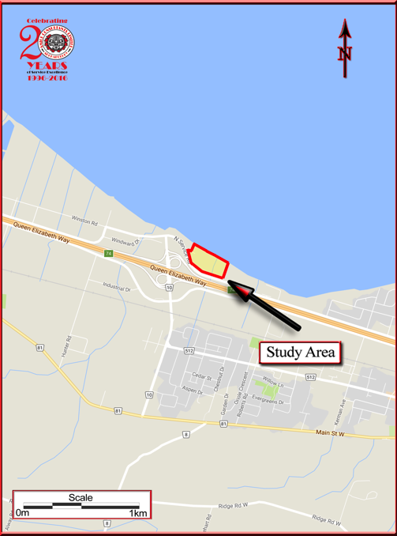

Map 1 Location of the Study Area (Google Maps 2012)

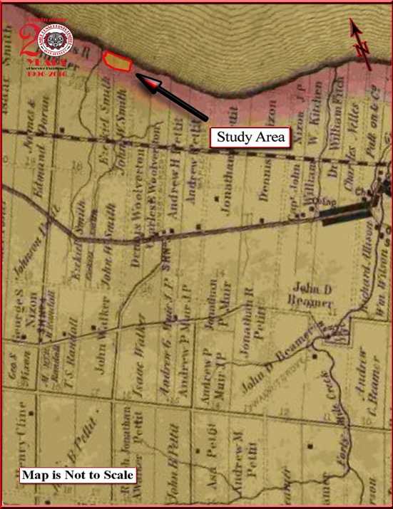

Map 2 Facsimile Segment of Tremaine’s Map of Lincoln and welland counties
(Tremaine 1859)

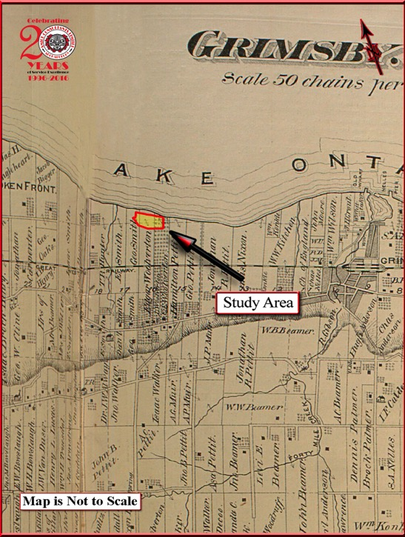

Map 3 Facsimile Segment of the Historic Atlas Map of lincoln and welland counties 1876

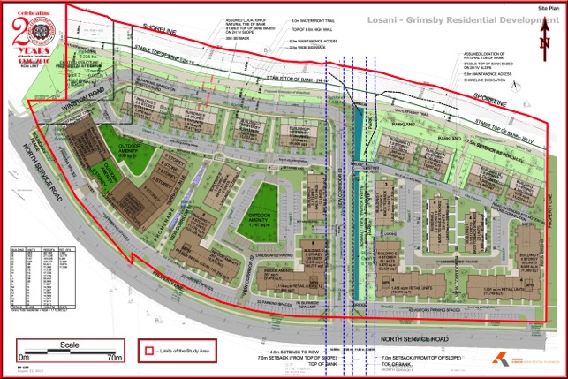

Map 4 Plan of Survey (A.T. McLaren LEGAL AND ENGINEERING SURVEYS

Limited 2015)

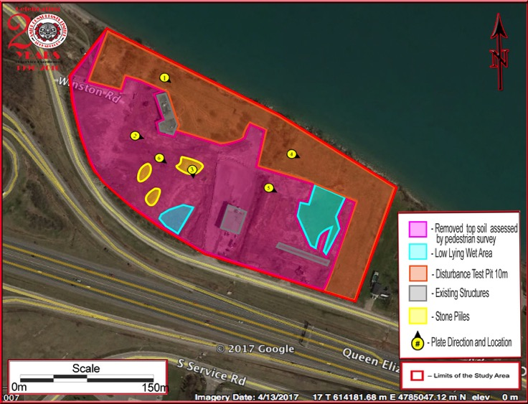

Map 5 Aerial Photo of the Study Area (Google Earth 2011)

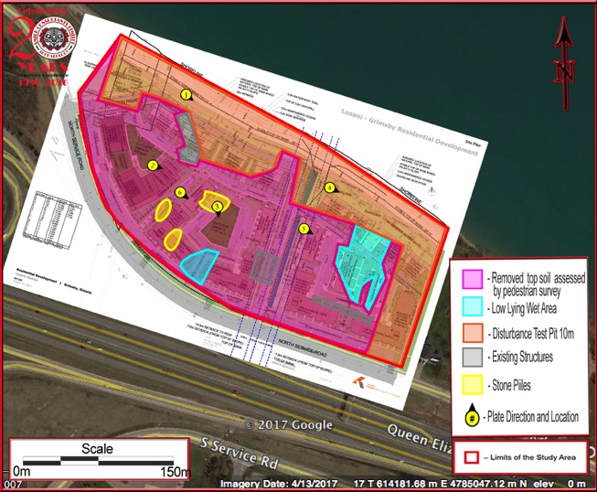

Map 6 Detailed Plan of the Study Area

13.0 Images
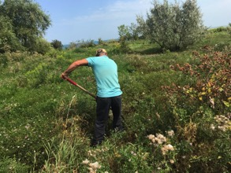 | 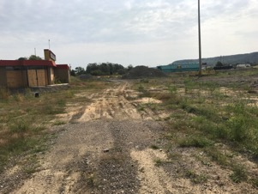
Image 1 Test Pit Conditions | Image 2 Pedestrian Survey Conditions
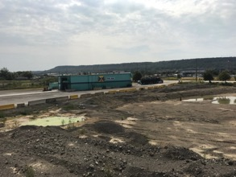 | 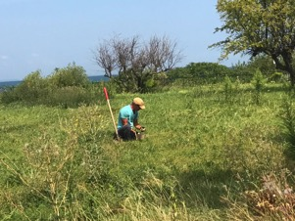
Image 3 View from Top of Stone Pile | Image 4 Test Pit Conditions
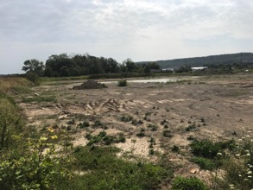 | 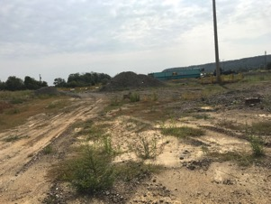
Image 5 Pedestrian Survey Conditions | Image 6 Pedestrian Survey Conditions

