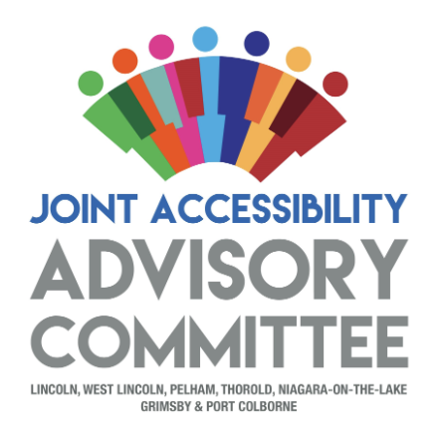

JAAC Accessibility Matters Award Nomination Questions
Award & Nomination Criteria
The following are eligible for nomination:
- Businesses
- Community Organizations
The Nominator
Your Name:
Address:
Email:
Phone Number:

The Nominee
Name of Nominee:

Please answer the following questions:
- In what area has the/your organization improved access for people with disabilities?

___Customer Service
___Information and Communication
___Built Environment
___Employment
___Transportation

- Please describe, in what way(s) has the/your organization improved access for people with disabilities?

Supporting documentation (photographs, plans, website information) is welcome. Nominations must be submitted by no later than 4 pm on May 8, 2025 by email at donna@theherringtongroup.ca . Nominations will be accepted from a third party or self-nominated. The 2025 award recipients will be announced during Accessibility Week, observed from May 25 to June 1, 2025.

